EXPT NO: 1 | BUILDING AND TRAINING A SIMPLE ARTIFICIAL NEURAL NETWORK (ANN) FOR REGRESSION AND CLASSIFICATION
DATE: 20.07.2026

PRE-LAB QUESTIONS (PROVIDE BRIEF ANSWERS TO THE FOLLOWING QUESTIONS)

- What is an Artificial Neural Network (ANN)?

An Artificial Neural Network (ANN) is a machine learning model inspired by the structure and working of the human brain. It consists of interconnected nodes (neurons) that process input data, learn patterns, and make predictions or classifications.

Example: Predicting house prices, recognizing handwritten digits, or detecting spam emails.

- What are the functions of the input, hidden, and output layers in an ANN?

Input Layer:
Receives the input data (features).
Passes the data to the hidden layers.
Example: Age, salary, and experience of a person.
Hidden Layer:
Performs calculations and learns complex relationships in the data.
Uses weights, biases, and activation functions to extract patterns.
Output Layer:
Produces the final prediction or result.
Example:
Classification: "Spam" or "Not Spam"
Regression: Predicted house price.

- Why is feature scaling important before training an ANN?

Feature scaling ensures that all input features are on a similar scale, preventing features with larger values from dominating the learning process.
Benefits:
Faster model convergence.
More stable and efficient training.
Improves prediction accuracy.
Prevents gradient-related issues.

- Differentiate between regression and classification problems with examples.

Regression | Classification
Predicts continuous numerical values. | Predicts discrete categories or classes.
Output is a number. | Output is a class label.
Example: Predicting house prices. | Example: Email spam detection.
Algorithms: Linear Regression, ANN (regression). | Algorithms: Logistic Regression, Decision Trees, ANN (classification).

- What is the role of the activation function in a neural network?

An activation function determines whether a neuron should be activated by introducing non-linearity into the network. This enables the ANN to learn complex patterns that cannot be modeled using only linear relationships.

Common activation functions:
ReLU (Rectified Linear Unit): Most commonly used in hidden layers.
Sigmoid: Used for binary classification outputs.
Tanh: Outputs values between -1 and 1.

AIM
To understand the implementation of Artificial Neural Networks (ANN) using TensorFlow and evaluate their performance on regression and classification problems.

SOFTWARE REQUIREMENTS
- Python 3.x
- Google Colab / Jupyter Notebook
- TensorFlow 2.x
- NumPy
- Pandas
- Matplotlib
- Scikit-learn

LEARNING OBJECTIVES
After completing this experiment, students will be able to:
- Understand the architecture of an Artificial Neural Network.
- Build an ANN for regression problems.
- Build an ANN for classification problems.
- Train and evaluate neural network models.
- Compare different evaluation metrics used for regression and classification.

THEORY
An Artificial Neural Network (ANN) is a machine learning model inspired by the human brain. It consists of interconnected neurons organized into layers.
A simple ANN contains:
- Input Layer
- Hidden Layer(s)
- Output Layer
During training, the ANN learns by updating weights using Backpropagation and an optimization algorithm such as Adam Optimizer.

PART A – ANN FOR REGRESSION
DATASET: California Housing Dataset
SOURCE: Scikit-learn
DESCRIPTION
- Samples: 20,640
- Features: 8
- Target: Median House Value

FEATURES
Feature | Description
MedInc | Median Income
HouseAge | House Age
AveRooms | Average Rooms
AveBedrms | Average Bedrooms
Population | Population
AveOccup | Average Occupancy
Latitude | Latitude
Longitude | Longitude

ALGORITHM
- Import libraries.
- Load California Housing dataset.
- Split into training and testing sets.
- Standardize the features.
- Build ANN model.
- Compile the model.
- Train the model.
- Predict house prices.
- Evaluate using:
  - MSE
  - MAE
  - RMSE

(CODE: CONATAINS STUDENT ROLL NOS
SCREENSHOT OF CODE
SCREENSHOT OF OUTPUT)

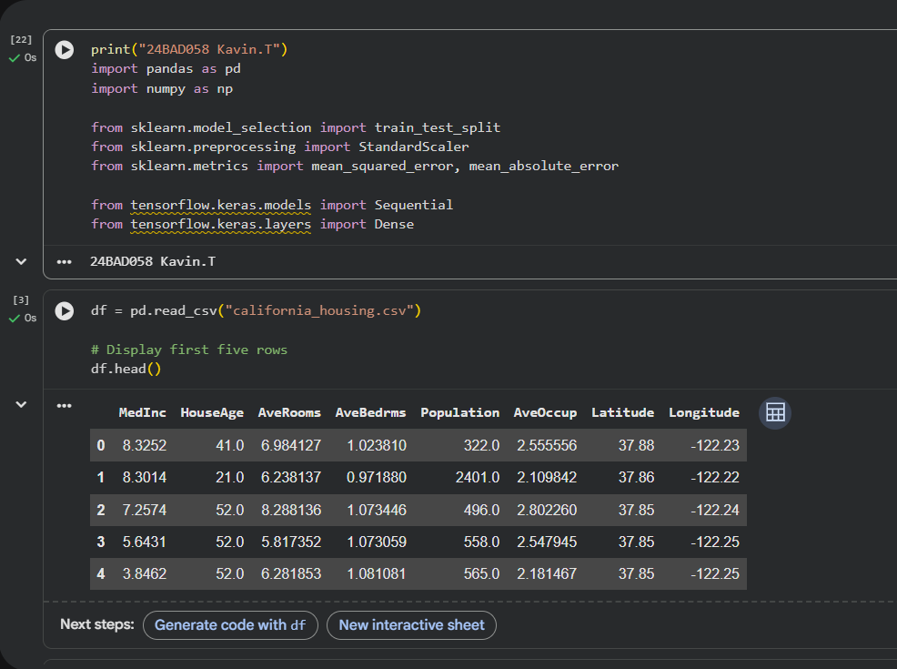

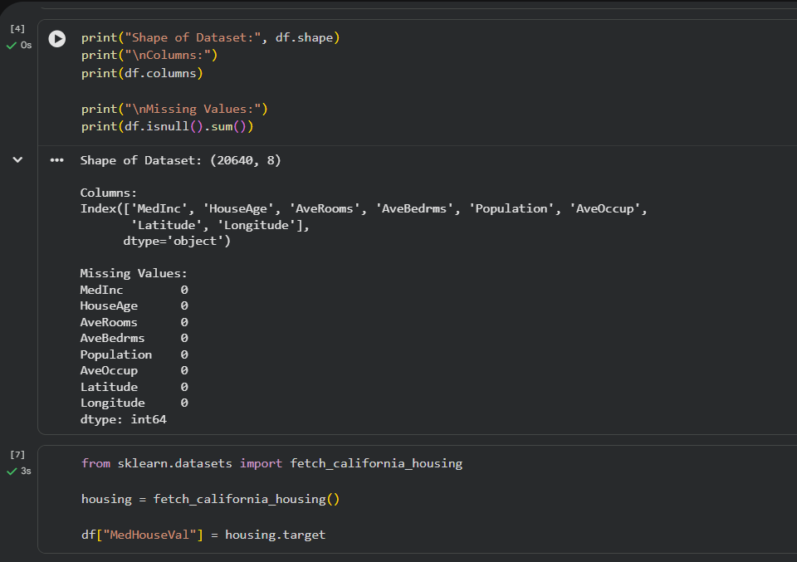

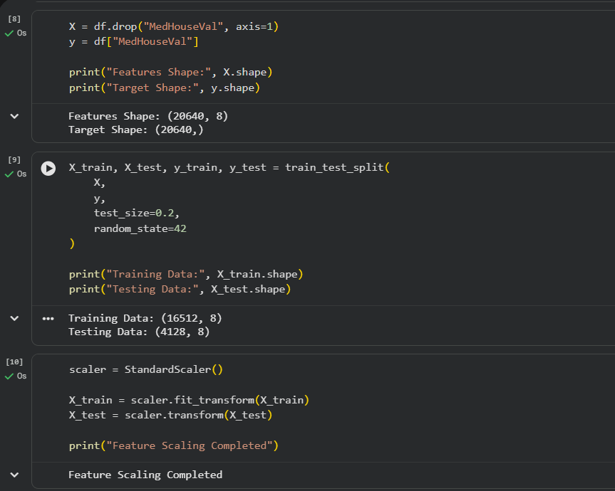

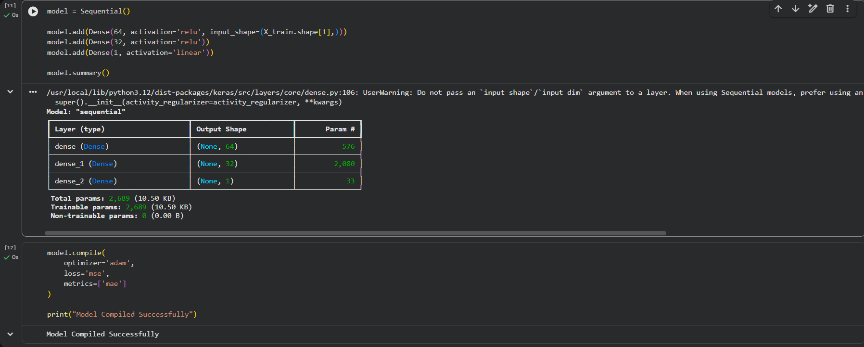

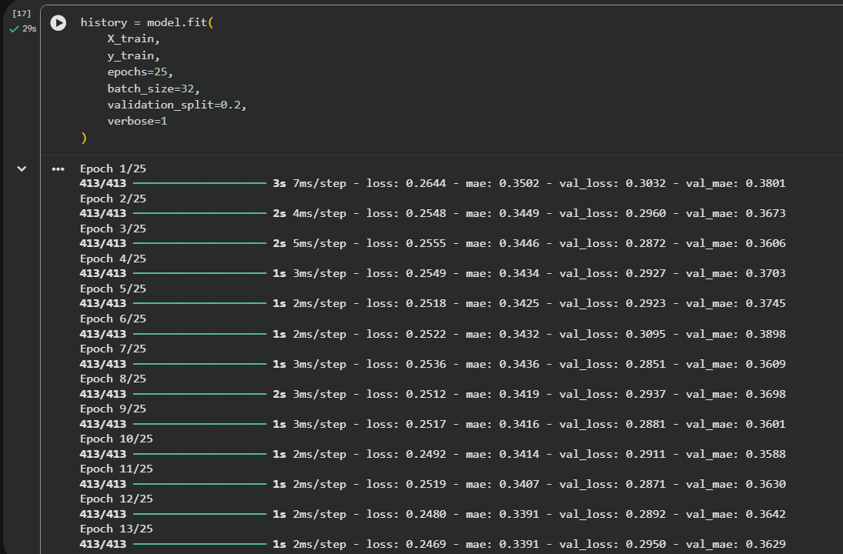

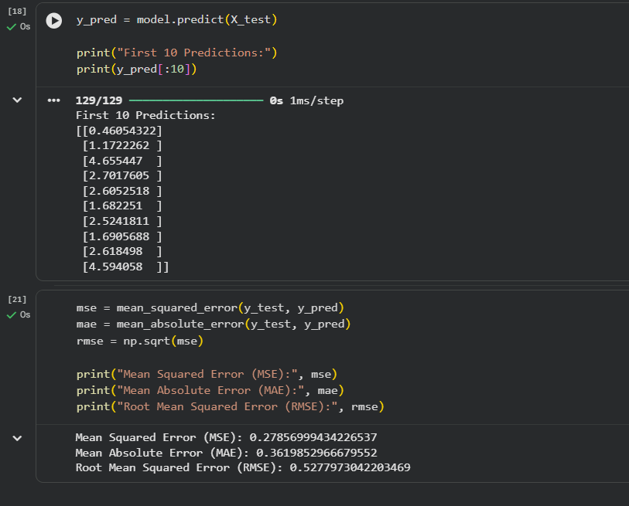

PART B – ANN FOR CLASSIFICATION
DATASET: Breast Cancer Wisconsin Dataset
SOURCE: Scikit-learn
DESCRIPTION
- Samples: 569
- Features: 30
- Classes:
  - Malignant
  - Benign

ALGORITHM
- Import libraries.
- Load Breast Cancer dataset.
- Split dataset.
- Standardize features.
- Design ANN.
- Compile model.
- Train model.
- Predict labels.
- Evaluate:
  - Accuracy
  - Precision
  - Recall
  - F1-score
  - Confusion Matrix

(CODE: CONATAINS STUDENT ROLL NOS
SCREENSHOT OF CODE
SCREENSHOT OF OUTPUT)

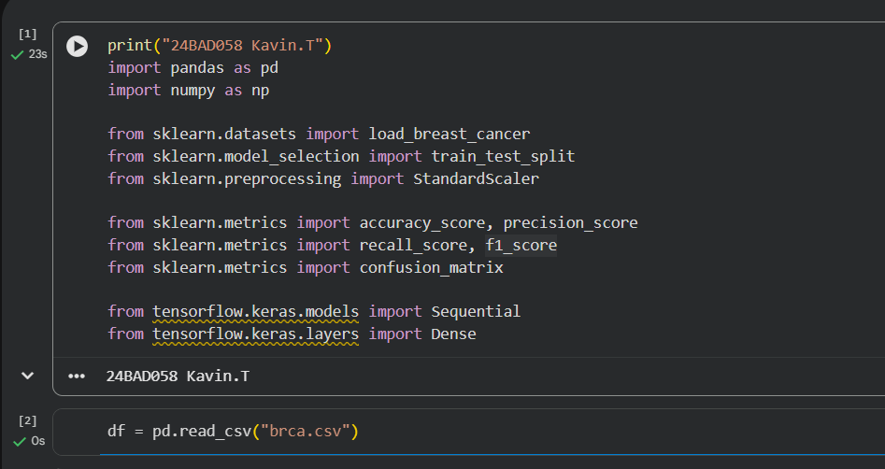

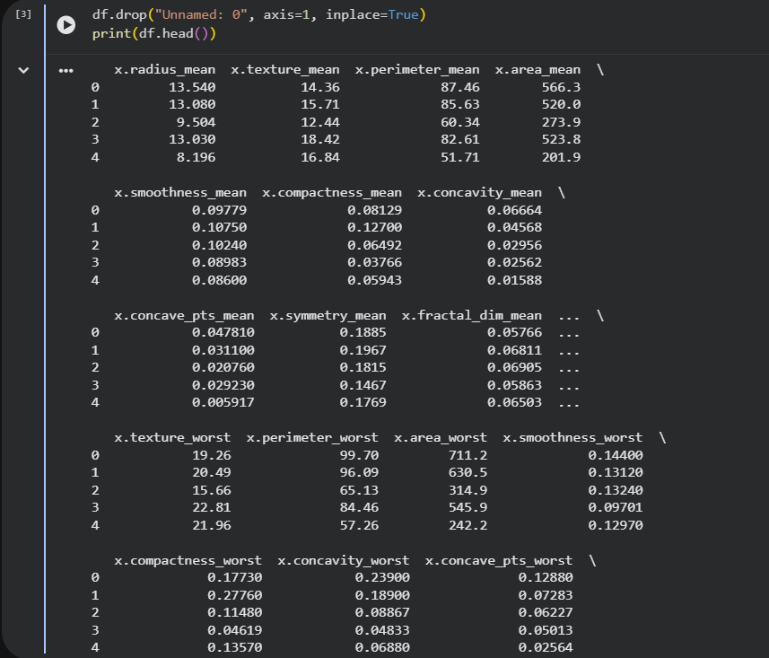

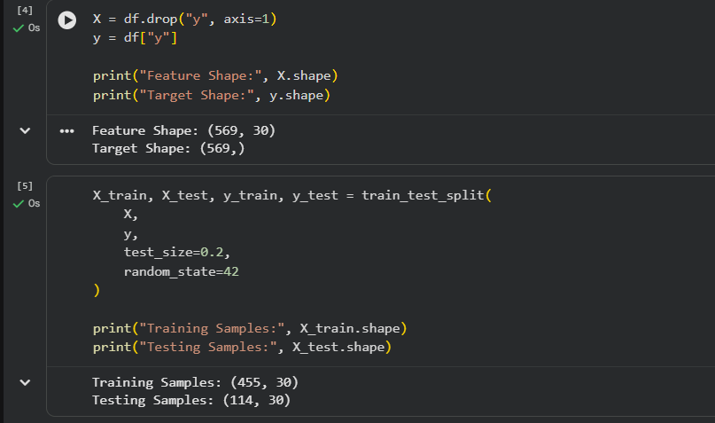

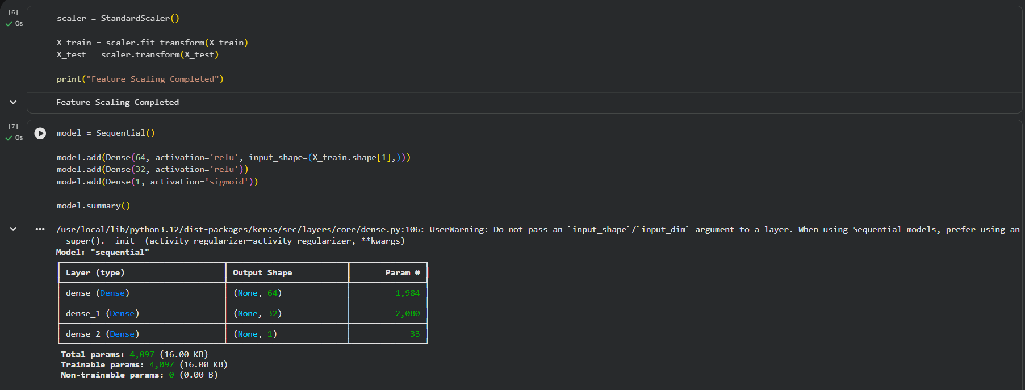

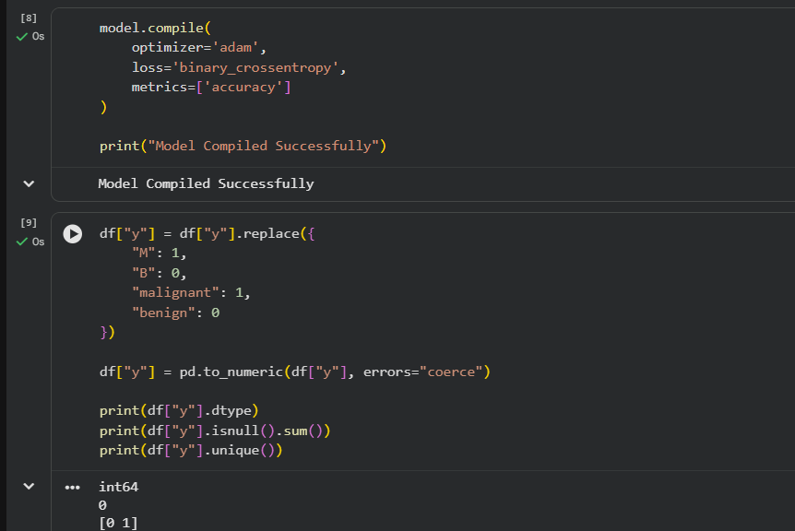
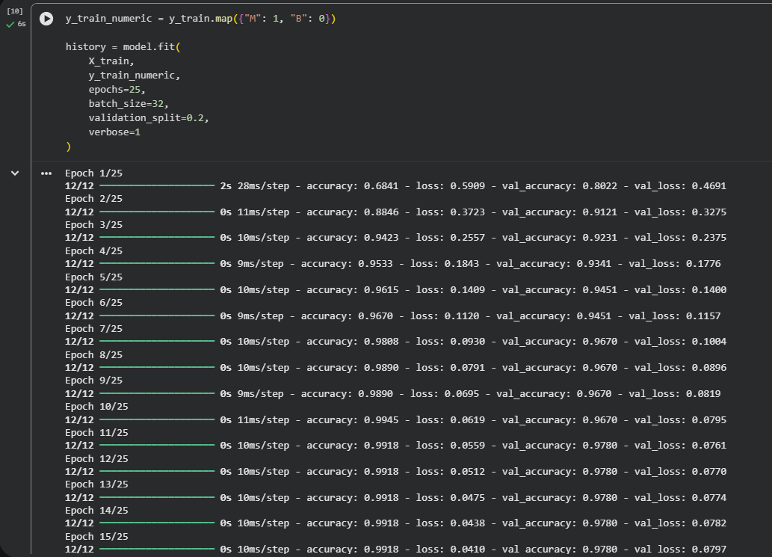
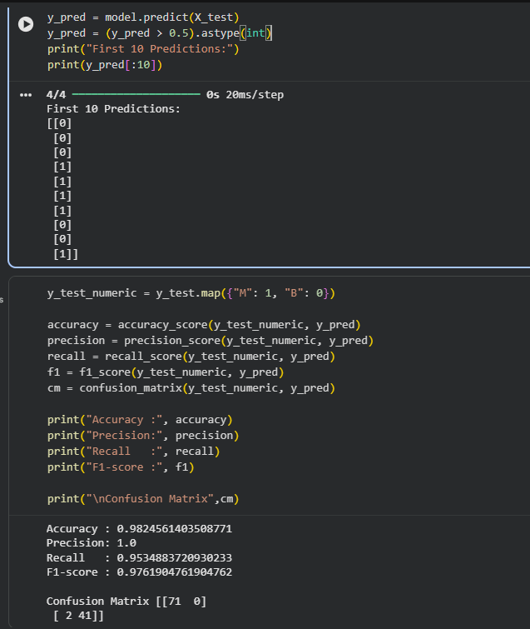

POST-LAB QUESTIONS (PROVIDE BRIEF ANSWERS TO THE FOLLOWING QUESTIONS)

- Why is the Adam optimizer commonly used in ANN training?

The Adam (Adaptive Moment Estimation) optimizer is commonly used because it combines the advantages of Momentum and RMSProp. It automatically adjusts the learning rate for each parameter, leading to faster and more stable convergence.

- Compare Mean Squared Error (MSE) and Mean Absolute Error (MAE). Which metric is more sensitive to outliers?

Mean Squared Error (MSE) | Mean Absolute Error (MAE)
Measures the average squared difference between actual and predicted values. | Measures the average absolute difference between actual and predicted values.
Squares the errors, giving more weight to larger errors. | Treats all the errors equally
More sensitive to outliers. | Less sensitive to outliers.
MSE is more sensitive to outliers because it squares the error values, making large errors contribute much more to the final metric.

- Why is the sigmoid activation function used in binary classification?

The sigmoid activation function converts the output into a value between 0 and 1, which can be interpreted as the probability of belonging to the positive class.
Reasons:
Produces probability values between 0 and 1.
Suitable for binary classification problems.
Works well with the binary cross-entropy loss function.
Formula:
$$σ(x)=\frac{1}{1+e^{-x}}$$
- How does increasing the number of hidden layers affect the performance of an ANN?

Increasing the number of hidden layers allows the ANN to learn more complex patterns and relationships in the data.
Advantages:
Learns complex and non-linear features.
Can improve accuracy on difficult problems.
Disadvantages:
Increases training time.
Requires more computational resources.
May lead to overfitting if the network becomes too deep.

- Compare the evaluation metrics used for regression and classification tasks. Why are different metrics required for these problems?

Regression | Classification
Predicts continuous numerical values. | Predicts discrete class labels.
Metrics: MSE, MAE, RMSE, R² Score | Metrics: Accuracy, Precision, Recall, F1-score, Confusion Matrix
Measures how close predictions are to actual numerical values | Measures how correctly the model classifies data into categories

Regression models are evaluated using metrics such as MSE, MAE, and RMSE because they predict continuous numerical values. Classification models use metrics like Accuracy, Precision, Recall, F1-score, and Confusion Matrix because they predict categorical labels. Different metrics are required because regression measures prediction errors, whereas classification measures how correctly the model assigns data to the correct class.

ASSESSMENT
Description | Max Marks | Marks Awarded
Pre Lab Exercise | 5
In Lab Exercise | 10
Post Lab Exercise | 5
Viva | 10
Total | 30
Faculty Signature

